IntroDUCKtion NewAdvisor Training 2018

Guiding New Students on the Journey to Graduation Lori Manson, Associate Director, loric@uoregon.edu
Office of Academic Advising
First-Year Advising Guideposts

Advising Appointment Checklist
- Is the student in or interested in joining a FIG or ARC? Check to see if they have other fall registration.
- Does the student have AP, IB, or other college credit that does not appear on their transfer evaluation report? If so remind them to send score reports or official transcripts to the Registrar’s Office.
- Is the student in the Clark Honors College?
- Does the student have a second language Admissions deficiency?
- Did the student take a placement in second language or math?

English Composition Placement

SAT EBRW March 2016- present (must meet both) | ACT–English | Placement
SAT ER 37  SAT EW 37 | 32 or above | WR 122 or 123
SAT ER 26-36  SAT EW 26-36 | 19–31 | WR 121
SAT ER 10-25  SAT EW 10-25 | 13–18 | WR 121 and WR 195
Second Language Starting Points

Language | Previous Study | Recommendation
Beginning a New Language | No previous study of language | Register for 101
Chinese and Japanese | Any previous study | Take placement and oral interview
French, German, Spanish | 2–3 years of high school study | Take placement
 | 4 or more years of study before college | Take placement or consult with department
All Other Languages | Any previous study | Consult with department
Students who have earned college-level credit for a second language may continue to the next course in the sequence with the exception of Chinese and Japanese which requires placement testing even if credit has been earned.

Math Placement
- Most students will have completed their test online and scores will be in the IntroDUCKtion Advising Summary.
- Students who did not take placements may do so at the EMU Computer Lab.
- Students who have college-level math credit are permitted to register for the next appropriate course as indicated in “Pre- requisites for Mathematics Courses” on page 9 of the Faculty Advising Manual.

Transfer Student Guideposts

General Education requirements in order listed on Degree Guide
Written English - WR 121 and WR 122 or 123 passed with grade of C-/P or above.

Faculty Advising Manual page 4
Bachelor of Arts Second Language - proficiency in a second language equivalent to two years of college- level study. Courses must be passed with grade of C-/P or above.
  - Faculty Advising Manual pages 11-13
  - BAsecondlanguage satisfying courses chartat registrar.uoregon.edu/current_students/ba_lang_satisfy

Note: second language requirements differ for students earning professional degrees including Bach- elor’s of Architecture, Fine Arts, Interior Architecture, Landscape Architecture, Education, and Music. See Faculty Advising Manual for more information
Bachelor of Science Mathematics/Computer and Information Science - proficiency in Math and/or Com- puter Information Science equivalent to a year (i.e. three courses) of college-level Math/CIS. Courses must be passed with grade of C-/P or above.
  - Faculty Advising Manual pages 6-10
  - Search on class schedule by BS Math (>4 or >5) at classes.uoregon.edu

Note: Math/CIS requirements differ for students earning professional degrees including Bachelor’s of Architecture, Fine Arts, Interior Architecture, Landscape Architecture, Education, and Music. See Faculty Advis- ing Manual for more information
Multicultural Requirement - 2 courses designated as multicultural; each course must be from a different multicultural area (there are 3 areas: American Cultures; (AC) Identity, Pluralism, and Tolerance (IP); and International Cultures (IC)
  - Faculty Advising Manual page 16; list of approved courses http://registrar.uoregon.edu/current-students/group- satisfying-and-multicultural-courses
  - Seach by multicultural area on class schedule at classes.uoregon.edu

Group Requirements - 15 credits minimum in each of three groups, Arts and Letters (>1), Social Science (>2), and Science (>3) and
    - 2 courses per group must be in the same subject code
    - at least 1 course per group must be in a different subject code
    - only 1 course in same subject code as first major can be used in the groups
    - a maximum of three courses in the same subject code can be used across all groups

Faculty Advising Manual page14
  - Comprehensive chart of approved group-satisfying courses http://registrar.uoregon.edu/current- students/group-satisfying-and-multicultural-courses
  - Seach by group (>1, >2, >3) on class schedule at classes.uoregon.edu

Note: Group requirements differ for students earning professional degrees including Bachelor’s of Architecture, Fine Arts, Interior Architecture, Landscape Architecture, Education, and Music. See Faculty Advising Manual for requirements for more information

First-Year Students

WrittenEnglish
Advising Scenarios

What is your writing course recommendation? FAM pg. 4
- Lori has SAT ER and EW scores of 26-36 and no transfer credit.
- Grant has an ACT score of 32 and no transfer credit.
- Lisa has SAT ER and EW scores of 10-25 and transfer credit from her local community college for WR 121.
- Cathy has SAT ER and EW scores of 26-36, but thinks she took an AP test at her high school.
- Jeff has an ACT score of 15 and no transfer credit.

Second Language

What is your second language recommendation? FAM pgs. 11-13
- Arturo wants to study Swahili, which he’s never taken before.
- Kerry took Spanish all through high school, and is thinking about continuing.
- Terrie has credit through French 201 from Lane Community College.
- Megan took the Spanish CLEP test and earned credit for Spanish 201–203.

Mathematics

What is your math recommendation? FAM pgs. 6-10
- Tami placed into MATH 101. She has no previous credit. She is interested in sciences.
- What if Tami were interested in majoring in Spanish?
- Karla has an AP score of 4 on Calculus AB. She is undeclared.
- Bil placed into MATH 111 and wants to major in Business or Economics.
- Stephanie placed in MATH 101. However, she feels this doesn’t reflect her math ability.

TransferStudent/DegreeAuditScenarios
Multicultural Requirement -- What does this student need to complete the Multicultural requirement? FAM pg. 16
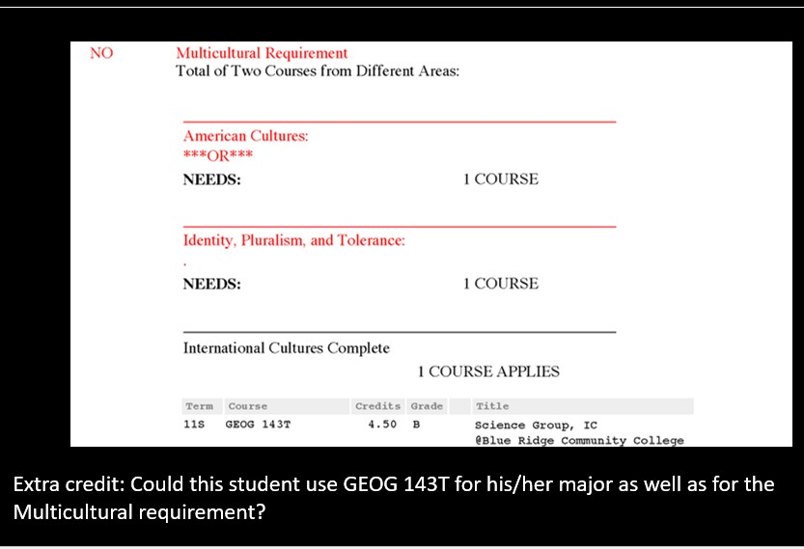

Bachelor of Arts Second Language

What do these students need to complete the BA requirement? FAM pgs. 11-13
- James has completed Russian 101, 102, and 103.
- Gloria would like to take Italian. She has not studied it previously.
- Kaylee took Spanish in high school and took a UO placement test. It shows she’s ready for Spanish 201.

Extra credit:
1. River is an international student from China. He is a native Chinese speaker.

Bachelor of Science Math/CIS

What do these students need to complete the BS math requirement? FAM pgs. 6-10
- Frank has completed MATH 105. He is earning a BS, however his major does not require particular math courses.
- Mary has credit for MATH 251 from Lane Community College. She is earning a BS, however, her major does not require particular math courses.
- Pat has completed MATH 111. He wants to major in Human Physiology, which requires students to complete either MATH 251 or MATH 246.
- Samantha has completed MATH 111 and MATH 243. She is a Psychology major.

Extra Credit:
- Megan is an Education Foundations major. She has completed MATH 211 (the first in the elementary mathematics sequence).
- Andrew has completed CIS 122. He is a Spanish major.
Group Requirements – What is needed to complete each group? FAM pg. 14
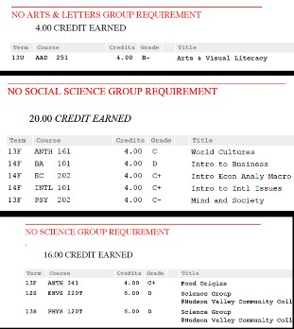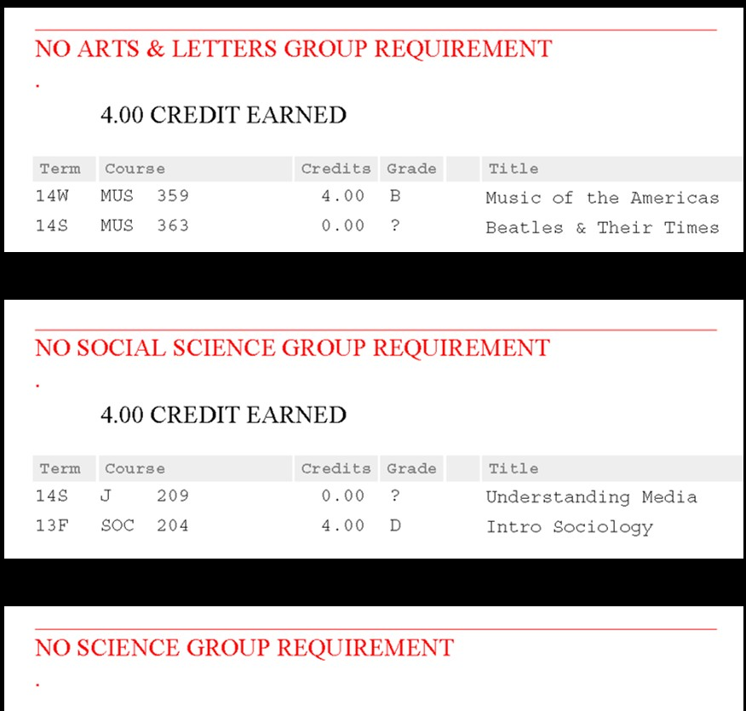

Extra Credit: If the student in the example on the right were an Anthropology major, how would this affect what course(s) she could take to complete the groups? What if the student is NOT an ANTH major? How many more ANTH can be used?

